Arcane Library

User Interface Design Document

#### **Table of Contents**

Page

## 1. Introduction

* 1. Purpose of This Document
  2. References

2. User Interface Standards

3. User Interface Walkthrough

4. Data Validation

5. Report Formats

Appendix A **-** Agreement Between Customer and Contractor

Appendix B – Peer Review Sign-off

Appendix C – Document Contributions

## **1. Introduction**

1.1 Purpose of This Document

The purpose of this document is to lay out and describe the visual aspects of the Arcane Library trading card organizer. The article is intended to be read and reviewed by the customer and any future developers of the app.

* 1. References

Lisenbee, J. R. (2021). (tech.). *Arcane Library System Requirements Specification* (pp. 1–9). Catonsville, Maryland: University of Maryland, Baltimore County.

1. **User Interface Standards**

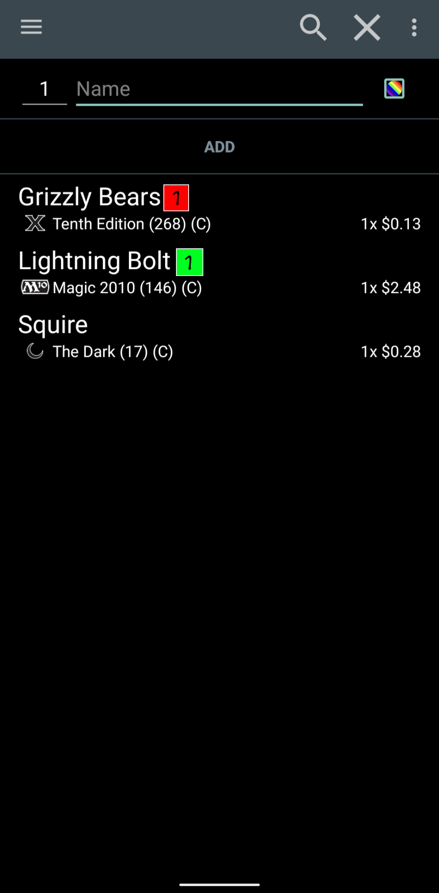

Above is a mockup of the main Collection page from the AL app. Shown is a collection with 3 card listings, each with one card, with pricing data loaded. From here, a user can search for the name of their card and click the add button, exit the app from the menu on the top left, clear their collection, and save the collection manually with the menu on the top right. When searching, a list of card name matches will appear below the search bar and the user can then add that card to the collection. Grizzly Bears and Lighting Bolt each have a tag with a label of 1. That means that for whatever tag that color is representing on that card, only one card is tagged for that purpose.

1. **User Interface Walkthrough**

There are no other screens or interfaces for this app, everything is self contained on the main screen and can be accessed from there.

1. **Data Validation**

* **Add Card Text Box:** String. Max 20 Characters. Formatted UTF-8 text characters.

**Appendix A – Agreement Between Customer and Contractor**

By signing this document, the customer agrees that this document is to be used as a description of the functionality and overview of use for the Arcane Library mobile app. They also agree that this document is subject to change at any time by request of either the AL development team or the customer based on the specifications below

Changes made to this document will require another round of sign-offs by all party members, the proposed schedule will be adjusted by an adequate amount as determined by the AL development team, and compensation renegotiated up to within 20% of the previously agreed amount. Changes to this document will not be reflected in the project planning until a maximum of 7 days after re-signing has occurred, during which period the changes may be negotiated without another signing.

| **Signer** | **Signature** |
| --- | --- |
| AL Development Team |  |
| Customer |  |

**Appendix B – Team Review Sign-off**

The AL Development Team has reviewed this document and found it sufficient to communicate to the customer the needs and requirements of the development team and customer.

| **Signer** | **Signature** |
| --- | --- |
| AL Development Team |  |
| Customer |  |